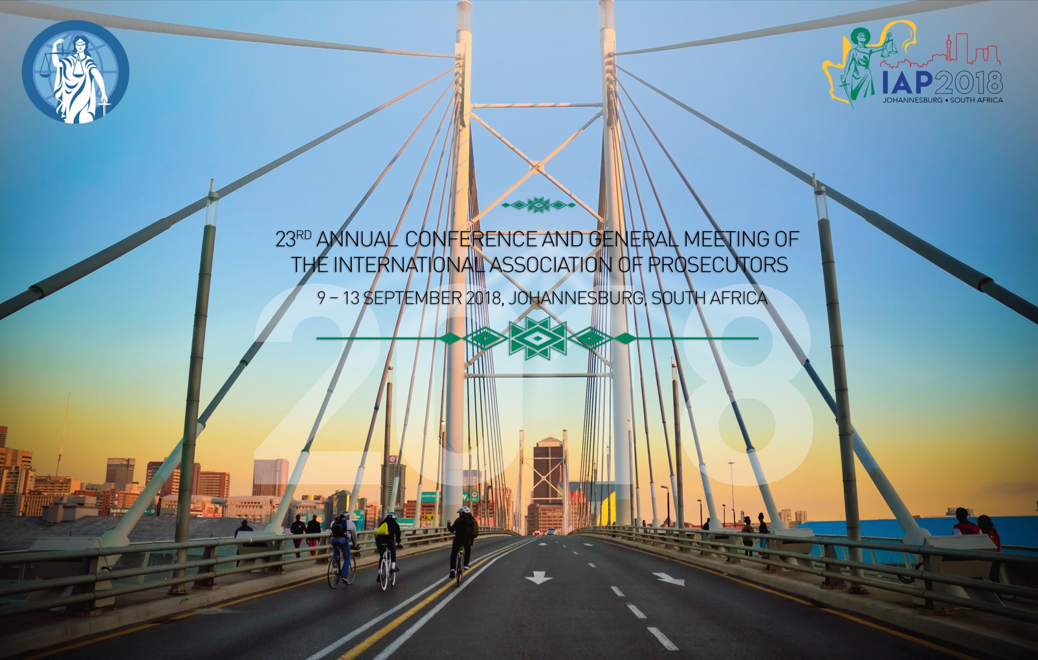
CONFERENCE PRE-REGISTRATION FORM

The online registration for the 23rd Annual Conference and General Meeting of the International Association of Prosecutors in Johannesburg, South Africa 9 – 13 September 2018 will open early April. This form is exclusively intended for those members, who needs to register for the event before the end of March 2018, due to budgetary restrictions.
PARTICIP ATION CATEGO RY
Full Participation 875 EUR (Early Bird) 950 EUR Full Cost Accompanying Person 425 EUR (Early Bird) 475 EUR Full Cost Day Participant 350 EUR per day
* Please tick the day(s) you wish to attend
Monday Tuesday Wednesday Thursday
PERSONAL INF ORMATION
Prefix (Mr, Ms, Mrs, Dr,…): First Name:

Middle Name: Last Name: Preferred name on name badge: Address 1:
Address 2: Zip (Postal Code): City: Country: Job Title:
- Prosecutor General □ Attorney General/Solicitor General

- Director of Public Prosecutions □ President of Association of Prosecutors

- Head of International Division □ Other: Organisation: Email Address: Work Phone: Mobile Phone: Passport Nationality: Passport Number: Passport Expiry Date: Special Dietary or Physical needs:
IAP MEMB ERSHI P CATEG O R Y
- Executive Committee Member (substitute) □ IAP Officials/Staff
- IAP Senate Member □ IAP Honorary Member
- Organizational Member Representative □ Individual Member
- IAP Contact Person □ IAP Invitee / Friend
ACCOMPAN YIN G PERSON
For an additional cost of 425 EUR, you can bring an accompanying person. Will you bring an accompanying Person? □ Yes □ No

Prefix (Mr, Ms, Mrs, Dr,…): First Name: Last Name: Preferred name on name badge: Select which Special Tours your Accompanying Person wishes to attend*:
- Accompanying Persons Half Day Tour (Monday 10 September2018)

- Accompanying Persons Full Day Tour (Wednesday 12 September 2018)

- Special dietary and/or physical needs:
S OCIAL E V E N T S
Attendance in all social programme events is included in your registration fee for participants and Accompanying Persons. Day participants are entitled to take part in social events taking place on the day of their participation.

Select which Social Program you wish to attend:

President’s Welcome Reception (Sunday 9 September 2018)
- Yes I will attend
- No I will not attend
Conference Dinner (Monday 10 September 2018)
- Yes I will attend
- No I will not attend
Networking Night (Tuesday 11 September 2018)
- Yes I will attend
- No I will not attend
Farewell Party (Thursday 13 September 2018)
- Yes I will attend
- No I will not attend
LETTER OF IN V I T A T I O N
On request, the Conference Unit will send a letter of invitation to attend the Conference. Such an invitation is extended specially to assist participants to obtain travel refunds, appropriate visas, approvals, sponsorships or leave. It does not imply any commitment on the part of the Conference organizers to provide any support, financial or otherwise.

    □ I need a letter of invitation □ I do not need a letter of invitation

CERTIFIC AT E O F A T T E N D A N C E
On request, the Conference Unit will issue a certificate of attendance

- I would like a certificate of attendance
- I do not need a certificate of attendance
BANK TRA NSFE R DETAIL S
The IAP Bank Account Details:
Please return this form to the IAP Secretariat ed@iap-association.org

Recipient | Stichting Treasury International Association of Prosecutors
Receiving Bank | ABN/AMRO Bank Koningskade 30, P.O. Box 165  2501 The Hague, The Netherlands
Account no. | 42.49.05.345
Currency | Euro
IBAN | NL07 ABNA 0424 9053 45
BIC | ABNANL2A

